

California State University of San Marcos

Jordan Fisher, Juan Gonzalez, Keith Gross, Miguel Morales , Noah Miera

CIS490 : Dr. Shaun-inn Wu

### Table of Contents

**Sushi Team -Team Norms**  4

1. **Application development**

1.1 Statement of Business Context 5

1.2 Statement of Customer’s Business Problem 5

1.3 Statement of Project Proposal 5

1.4 Statement of Deliverables 5

1.5 Measures of Success 6

1.6 System Overview 6

1. **Requirements Matrix** 7
2. **Project Management**

3.1 Product Breakdown Structure 8

3.2 Work Breakdown Structure 9

3.3 Initial Schedule for Tasks and Deliverables 10-12

3.4 Statement of Total Price 12

3.5 Gantt Chart (Phases 0-2 only -Due to technical difficulties) 13-14

3.6 Initial Project Cost Tracking Chart 15

3.7 Statement of Deliverables 16

3.8 Outline of Resources Needed 16

1. **Team - Appendix**

4.1 Access to Project 17

4.2 Attendance Records 17

4.3 Team Information 18-26

To: Jared Macshane, Machine Learning Supervisor

CC: Dr. Shaun-inn Wu, Director of Projects

The Sushi Team is grateful to be able to be part of this for Keep America Beautiful. Thank you Jared, as well as Dr. Wesley Schultz, for not only this opportunity to work in the Machine Learning field for this project, but also to work on something that helps build and maintain clean, green, and beautiful spaces in America. We look forward to working and learning from you this Spring semester of 2022, in order to assist in the making of this project.

In this first phase, the team went over documentation and code from TACO, a growing image dataset of waste in the wild, in which the images are labeled and segmented according to a hierarchical taxonomy to train and evaluate object detection algorithms. We are doing so in order to learn more about their pre-trained Mask R-CNN model, and see if we can adapt it to our needs to categorize litter in Google Street images we have collected/annotated for initial future endeavors. We have also connected to a Google Cloud server, in a Anaconda/Miniconda environment, to progress together in the creation of code necessary for this new ML algorithm. In the next coming phase, we will strive to delve deeper into, and finalize, our requirements and resources needed, as we move towards a functional and usable Machine Learning algorithm that the Web App team can utilize, under Jared’s supervision.

Regarding the projected cost of this project, the Sushi Team has determined that we will “charge” a rate of $23 per hour, per member of our team. In this first phase, we have accumulated a cost of $3,249, through 141.25 hours. In the next phase, we estimate a cost of $2,858, through 124.25 hours. With this rate in mind, we estimate the total cost of the project to come to a total of $15,203, through a total projected 661 work hours in the end. With additional estimated monthly costs of a Google Cloud server, $50 per month, for the 4 months of development, this will total out to $15,403. Should alternative or additional costs become required, these will be updated accordingly.

By signing below, you hereby approve Sushi Team to continue working on the following project: Keeping America Beautiful: Litter Detective and agree to the aforementioned estimated costs.

_________________________________________

Jared Macshane, Machine Learning Supervisor

From, Team/Scrum Leader: Noah Miera

### Sushi Team - Team Norms

● **On time:** Team members will arrive on time. If team members are unable to arrive on time, they will make an effort to notify the team. Absences for emergencies will be excused so long as the team and Professor Wu are made aware of them.

● **Respectful:** Team members will act respectfully towards each other and bullying, harassment, and similar forms of disrespect are prohibited.

● **Willing to learn:** Each team member will be asked to learn new information and skills to complete their work on this project. This learning will both be inside and outside of the classroom.

● **Open to help:** If a teammate is struggling with an aspect of their work, they are expected to ask for help. Similarly when asked for help, team members are expected to assist their teammate so long as they are reasonably able.

● **Communication:** General team communication will be done via the group’s Discord channel.

● **Quality:** Team members are expected to finish their tasks at the best quality possible, satisfying the client. If work is considered poor quality by the rest of the team, it will be redone.

### 1. Application Development

**1.1 Statement of Business Context**

Keep America Beautiful is a leading national nonprofit organization that inspires and educates people to take action every day to improve and beautify their community environment. They envision a country in which every community is a clean, green, and beautiful place to live.

**1.2 Statement of Customer’s Business Problem**

* Need a new Machine Learning algorithm to produce data on Google Street images containing litter.
* Needs the data to not only detect if there is litter, but also categorize them.
* Make the results available and usable for the Web App team.

**1.3 Statement of Project Proposal**

* 1. Process Google Street images through a pre-trained model.
* 2. Adapt model to our specific needs of litter detection.
* 3. Collect output data/results.
* 4. Sync up input/output format with the Web App team.
* 5. Make results accessible to the Web App team.

**1.4 Statement of Deliverables**

* Machine Learning code/algorithm that will be compatible and usable with the Web App team.
* Algorithm will produce data that will include:
  + Identification of litter in an image.
  + The total amount of litter.
  + Categorize the litter (e.g. Plastic bottle, Paper bag).
  + Show the detection accuracy (e.g. 90% sure this is a Plastic bottle-Litter).

We will strive to deliver a new Machine Learning algorithm for Keep America Beautiful, developed through Python in a Anaconda/Miniconda environment, that will output usable and available results for the Web App team.

**1.5 Measures of Success**

The Sushi Team will perform the following tasks in order to accomplish the requirements listed in the proposal.

* JAD #1 - Identify initial requirements and technical specifications for the project.
  + Connect to a Google Cloud Server.
  + Establish Anaconda/Miniconda environment.
  + Read documentation/code of TACO’s pre-trained model.
  + Collect/Annotate Google Street images for future initial testing.
* JAD #2 - Identify the final requirements and technical specifications for the project.
* Prototype #1 - Process images through the Machine Learning algorithm to produce litter metrics.
* Prototype #2 - Able to sync up the input/output format of the Machine Learning algorithm with the Web App team.
* Final Product - Collation and transfer of litter metrics from images, received by the Web App team, that have been processed through a Machine Learning algorithm, for use by the Web App team.

**1.6 System Overview**

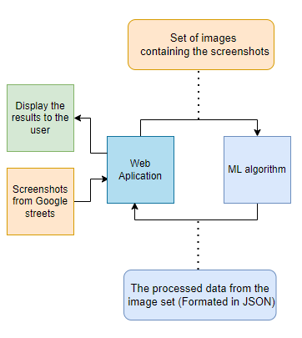

### 2. Requirements Matrix

| REQ # | Requirement name | Description | Critical | Implemented | Task ID |
| --- | --- | --- | --- | --- | --- |
| 1 | Process Google Street images | Google Street image datasets can process through a Mask R-CNN model. | Y | N | 3.6.1 / 3.6.4  3.6.9 / 3.6.10  4.2.2 |
| 2 | Litter Detection | The algorithm will identify the presence of litter in Google Street images, as well as classify them. | Y | N | 4.5.1 / 4.5.2  4.5.7 / 5.2.2  5.2.9 |
| 3 | Prepare Image Metrics | The Machine Learning program will process the algorithm’s litter results. | Y | N | 5.5.2 / 5.5.8 |
| 4 | Send Prepared Metrics | Once the results have been prepared, the program will deliver the metrics to the Web App team. | Y | N | 6.2.2 / 6.2.9  6.2.15 |

### 3. Project Management

**3.1 Product Breakdown Structure**

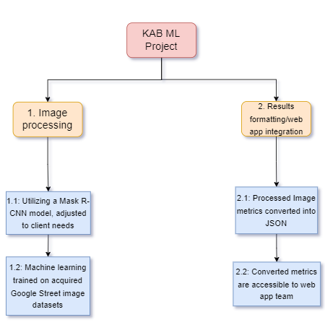

**3.2 Work Breakdown Structure**

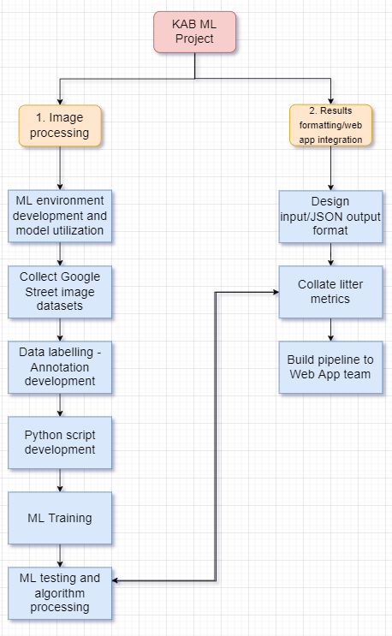

**3.3 Initial Schedule for Tasks and Deliverables**

List of Tasks

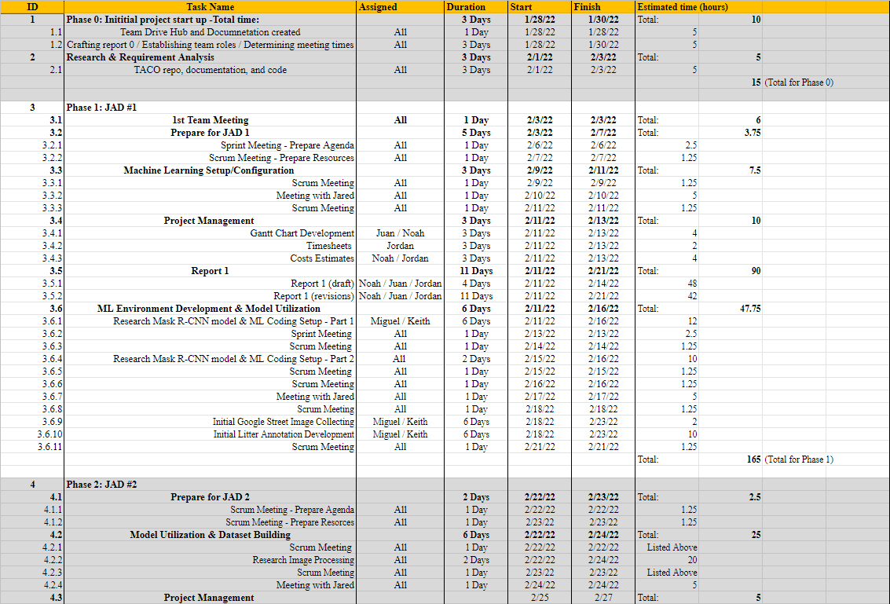

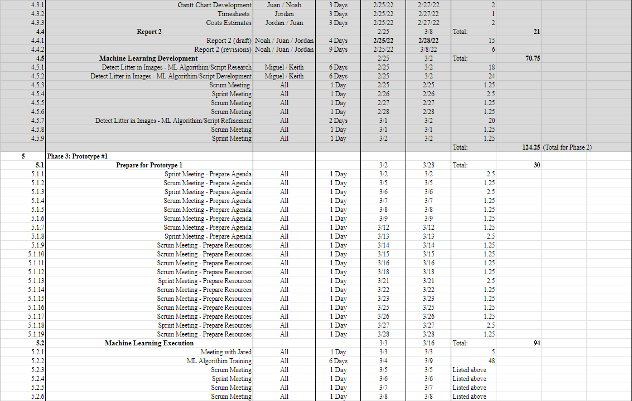

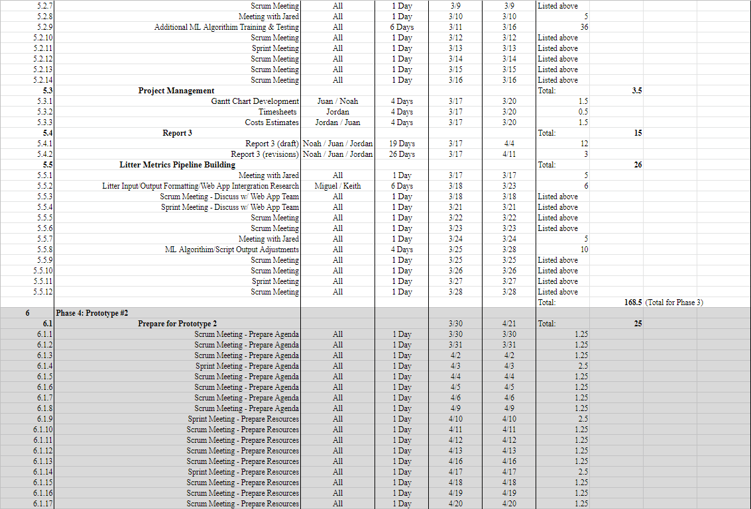

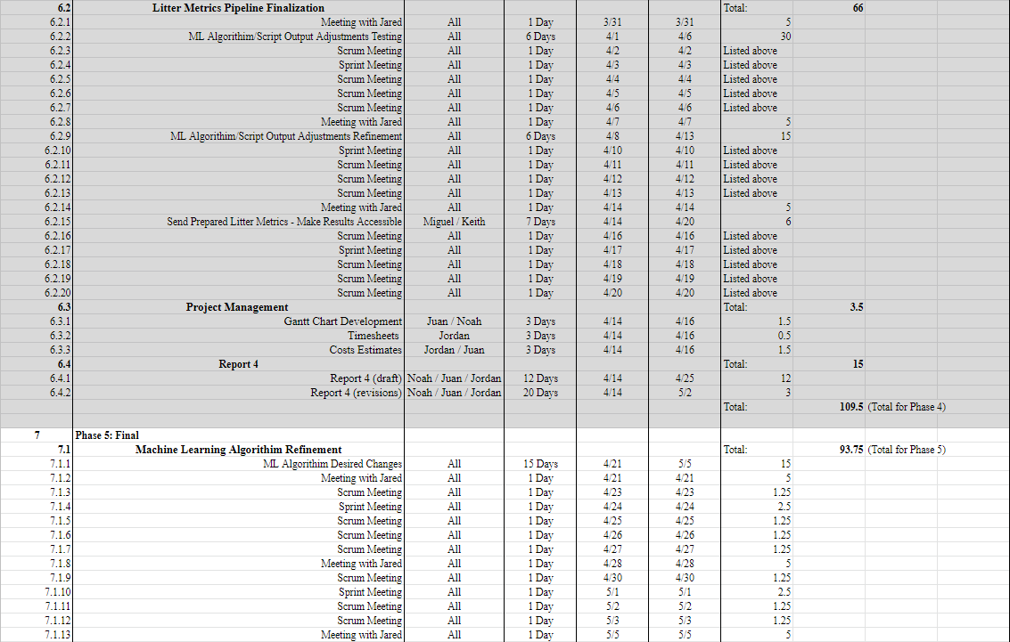

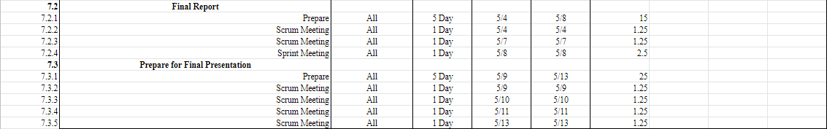

**3.4 Statement of Total Price**

We will be charging a flat rate of $23.00 per hour for each member of the Sushi Team. Through phase 1 of the project, it was estimated that the cost will be $3,795. This is based on around 165 hours of work done by the team in this phase. In actuality, the cost was $3,249, with 141.25 hours of work.

During phase 2 all the members are estimated to put together a total of 124.25 working hours. This means the costs for this phase will be $ 2,858.

During phase 3 of the project, the Sushi Team is projected to work for 168.5 hours. The cost will be $3786 for the phase.

During phase 4 of the project, the total number of estimated working hours spent towards development amounted to 109.5 hours, with a cost of $2,519 total.

During phase 5 of the project, the total number of estimated working hours spent towards development amounted to 93.75 hours. Thus, the total cost for this phase will be $2,156.

The final cost of this project is projected to be $15,203, with 661 hours spent by the team towards the development of the litter detection algorithm. However, with additional estimated monthly costs of a Google Cloud server, $50 per month, for the 4 months of development, this will total out to $15,403. Should alternative or additional costs become required, these will be updated accordingly.

**3.5 Gantt Chart (Phases 0-2 only - Due to current technical limitations)**

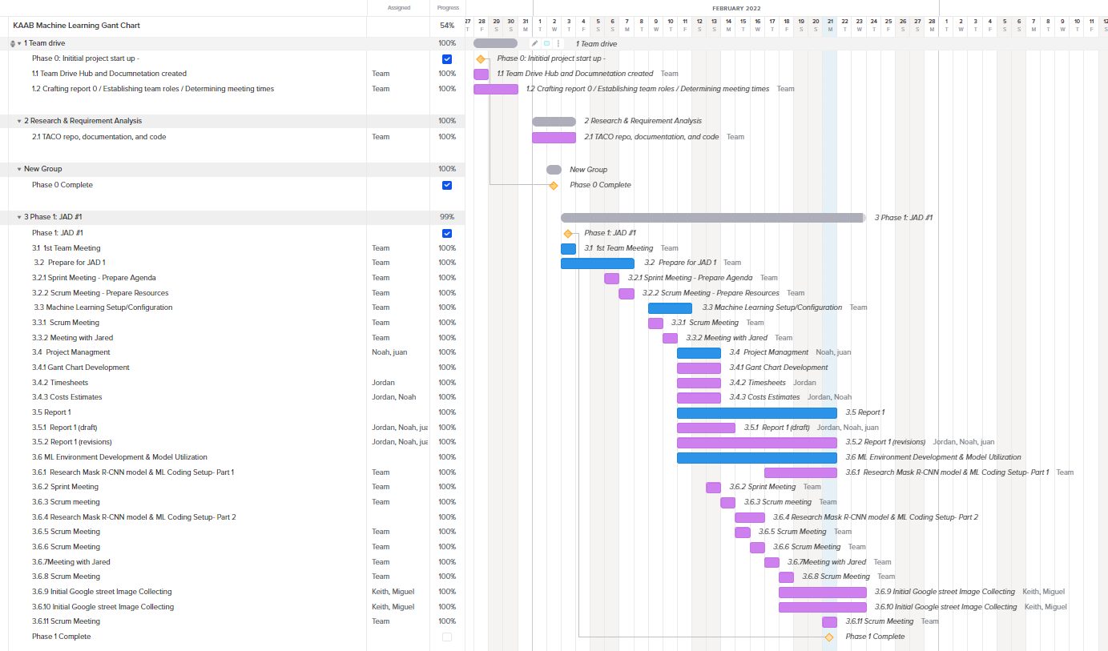

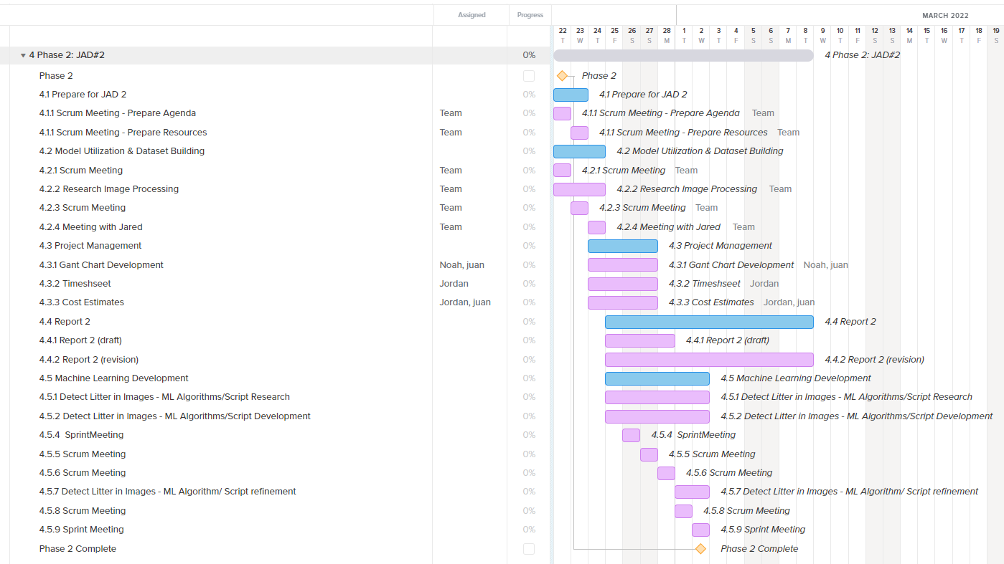

Note: Online environment required a premium subscription to include additional tasks to be included within the same project, which led to us including the maximum tasks it allows for our Gantt chart, showing up until Phase 2. We are striving to migrate to Microsoft Project Manager, but will need a little time to adjust to it completely.

**3.6 Initial Project Cost Tracking Chart**

(As of now, up to Phase 1)

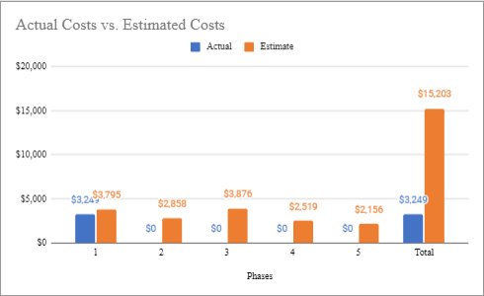

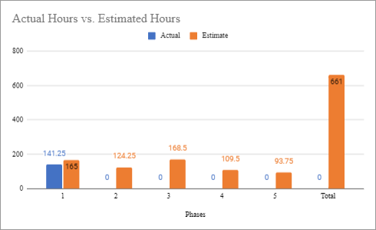

The above chart tracks the estimated and actual costs/hours for each phase of the project as well as our total accumulated costs compared to our estimated costs. We will assume an hourly rate of $23.00 per hour for this project, as we estimate to work a total of 661 hours.

**3.7 Statement of Deliverables**

The Sushi Team strives to deliver the following final products:

* A fully working machine learning algorithm that will detect instances of litter in an image and identify the type of each instance.
* A scheduling hook by which the web app team can use this algorithm by sending a set of images.
* A system to format the data collected from the set of the set of images sent using the web application.
* A system to send the formatted data back to the web application for further use as determined by the web app team.

**3.8 Outline of Resources Needed**

The following are what the Sushi Team will be supplying:

* Knowledge of Python code, documentation, and implementation.
* Updated documentation.
* Research and testing.

The following resources are what the Sushi Team will need supplied from Jared Macshane:

* References and guidance of Machine Learning through existing models & open-source data.
* Google Cloud Server Instance and Funding.
* Signage and approval for the Sushi Team to continue working on the project.
* Availability for future meetings.
* Access to Keep America Beautiful’s private server.
* Possible extra student labor to assist in Google Street image annotations.

### 4. Team - Appendix

**4.1 Access to Project**

The following will be how the Sushi Team will be collarbaring during this project so-far:

* Discord.
  + https://discord.gg/dr5785e9
* GitHUB
  + https://github.com/JuanGonzalez2020/KAAB-ML
* Google Cloud Server Instance.
  + Access is granted by Jared by giving him your SSH public key.
  + ssh username@34.125.176.184

**4.2 Attendance Records**

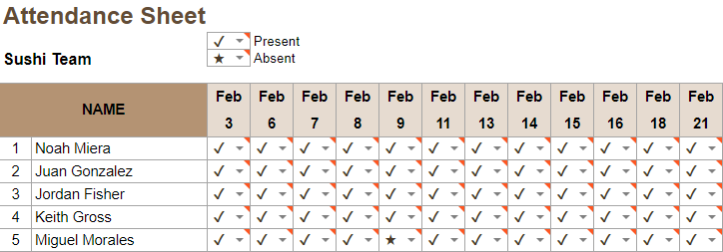

**4.4 Team Information**

|  | Noah Miera  Team/Scrum Leader  While I do not have experience working in Machine Learning, or Object Detection before, I do have experience working in Python, the language for this project, according to Jared. I believe I will work well as Team/Scrum Leader, due to me being in similar positions for other past school projects, non-school events, and work. I will strive to maintain continuity and consistency throughout this project. |
| --- | --- |
|  | Juan Gonzalez  Project Manager  I have worked on two machine learning based projects in the past where I understood that cleaning up a data set is essential to acquiring desired outcomes. I’ve solely worked with numerical data when implementing machine learning and have not worked with image processing. My experience working with Sushi Team as Project Manager has involved high amounts of communication among the team in order to organize and manage tasks to meet requirements. Taking advantage of modern Project managing apps will be key to our success. |
|  | Jordan Fisher  Documentation/Training  My primary contribution to the Sushi team is ensuring that the team lead and project manager have access to clean organized information and creating accurate and descriptive diagrams to better communicate said information. In my scholastic and professional life I have filled similar roles such as in the numerous group projects where I took on such responsibilities. |

|  | Keith Gross  Programmer  My background working in Test Engineering and the U.S. Navy has provided me with the skills needed to develop solutions for complex problems I may not have a background in. While I don’t have a background in Machine Learning I am able to find the resources we need to develop our machine learning algorithm and program, program a solution, then resolve any issues that present themselves during our test cases. |
| --- | --- |
|  | Miguel Morales  Programmer  Miguel Morales is a programmer for Sushi Team. Mr Morales has experience in several programming languages such as C/c++, Java and Python. The programming role is well suited because of his adaptability skills to learn and approach computer problems. |

**Resumes**



